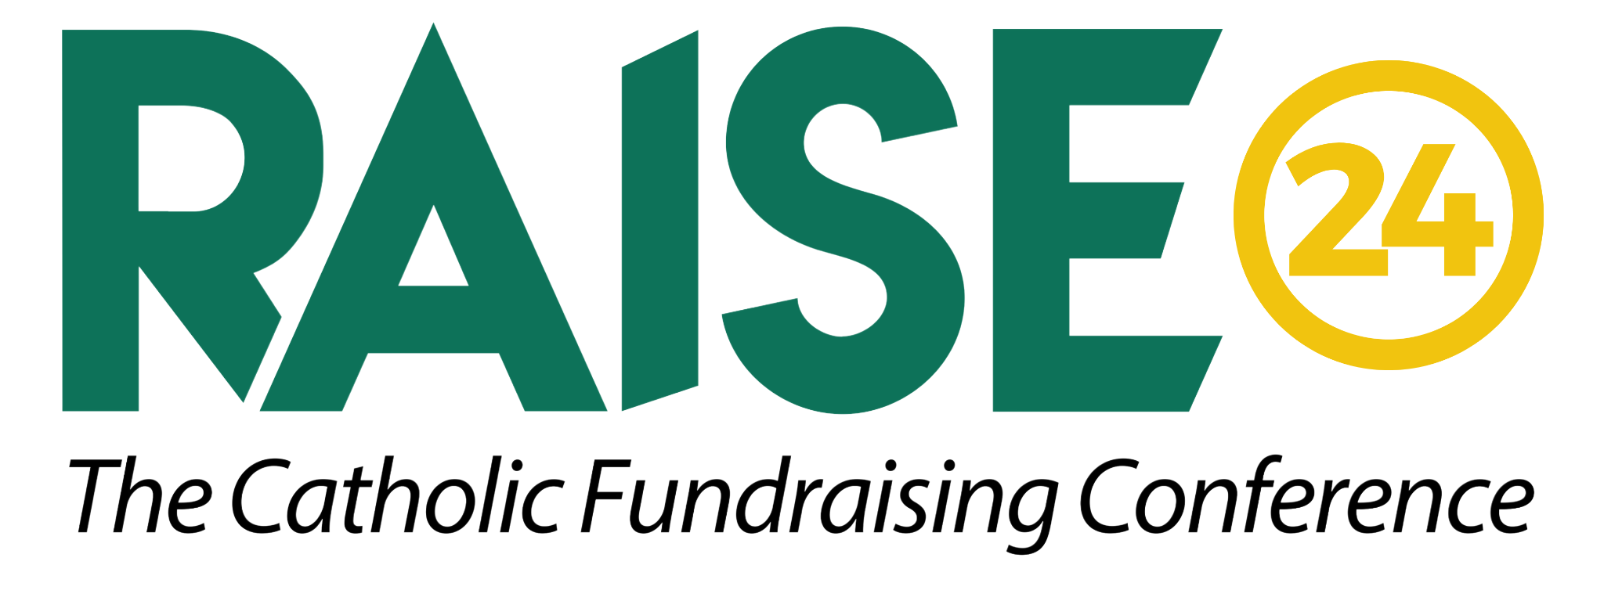
www.petrusdevelopment.com/raise24
RAISE is the best return-on-investment out there for professional development and increasing the effectiveness of your development team. Great for new development professionals or seasoned veterans looking for proven strategies and tactics.
FAQ
What if we just hired new members for our development team?
RAISE is the perfect way to jumpstart your new team members. Three days of intensive training and coaching gives your new development professionals the tools they need to succeed.
Why should I go if I went before?
Not only will you learn new, cutting edge strategies and techniques this year, but you can also bring more of your team along. With an incredible location, new speakers, and yet another opportunity to work one-on-one with the Petrus Development Consultant Team, make your organization better than ever this year by investing in RAISE24.
How will this benefit the organization I work for?
Conference attendees will acquire:
- Tools & techniques to increase fundraising dollars earned
- Practical tactics to increase productivity and efficacy
- Confidence in a clear strategy forward for your organization
- Inspiration and support to grow and develop new revenue streams to raise more money for your mission
- New technologies or vendors that will keep your donor experiences relevant and authentic
- Case Studies with meaningful examples and takeaways you can implement right away
- Teambuilding & development of your team, if you are sending a group of attendees, to ensure the collaboration needed to meet your fundraising goals
- Network in-person with similar individuals and organizations
- Opportunity to discuss problems and challenges that you are facing with your peers allowing creative problem-solving and impactful brainstorming
- Establish future partnership/ministry opportunities resulting from authentic conversations and connections
- Access to the entire Petrus consulting team for three days, compared to paying a consultant for three days. Major savings!
Sample Justification Letter
Dear [Supervisor’s Name],
I was recently researching professional development opportunities and I came across RAISE24, the Catholic Fundraising Conference taking place June 24-26, 2024 in San Antonio, Texas. Based on my research Petrus Development, who hosts the conference, is an industry leader in coaching organizations to succeed in their fundraising goals.
RAISE brings together development professionals from across the nation to address concerns, share ideas and activities that will be beneficial to [our organization]. The conference offers effective strategies, best practices, and tools via presentations, discussions and networking with development professionals and fundraising experts. Sessions will cover topics every development officer needs to know to be successful from getting appointments to closing gifts.
Here’s how my attendance will be a positive return on investment for our [organization]:
- I will learn how to establish and improve our development efforts through tools and techniques that will increase fundraising dollars earned year over year.
- I will have the chance to engage in deeper discussions with my peers about how to effectively address funding issues facing Catholic organizations.
- It will give me access to three days of one-on-one consulting opportunities with the entire Petrus Development Consultant Team - an incredible savings!
- I will gain confidence in a clear strategy forward for our organization.
Here’s the cost breakdown of sending me to the Petrus Leadership Conference:
● Registration: $999
● Airfare: $
● Hotel: $507 (3 nights stay @ $169/nt) ● Meals: $
Total travel costs: $
Total conference costs: $

What’s included in the cost?
- 3 days and 3 nights at the Contessa Hotel
- Lunches daily
- Dinner event on second night
- 3 days of access to Petrus Consulting Team
- Hours of intentional networking time amongst development professionals
This is a good investment of time and resources that will deliver real value to our organization. Thank you for your consideration.
Sincerely,
[signed]

